Highcliffe School Student Bulletin
Monday 6th November - Friday 10th November 2006: Week A

Thought For The Week:
Remember the cost of war and the price of freedom.

News Story of the Week:
World's biggest ship brings Xmas
See http://news.bbc.co.uk/cbbcnews/hi/uk/default.stm
for more details and other news stories!

Shoebox Appeal: Thank you for all your interest in the Christmas Shoebox Appeal so far. To date, we have sold 200 boxes and 20 have been returned. If you have not bought a box yet, please could you do this in the next few days!

Year 11 Science Module tests:
Wednesday 8th November 2006 Lesson 1 (with some catch ups lesson 2).
- Make sure you know where you are sitting (seating plans should be displayed in tutor rooms and outside exams office).
- Bring along pencils, rubbers, calculators and statements of entry.
- Revision classes take place on Monday and Tuesday see Science noticeboard, monitors or a science teacher to find out where.

Year 10 Students - Module 1 Mathematics exam Monday 13th November. You will need a calculator, pencil, pen, eraser, ruler, protractor and pair of compasses. The exam will start at 1.20pm so prompt arrival is essential.

Year 10 Students - Module 1 Mathematics Revision session: Wednesday 8th November, 3.20pm - 4.20pm. Higher tier go to M4; Foundation Tier go to M3.

Chemistry Week
6th – 9th November 2006

6th - 9th November is Chemistry Week here at Highcliffe School!
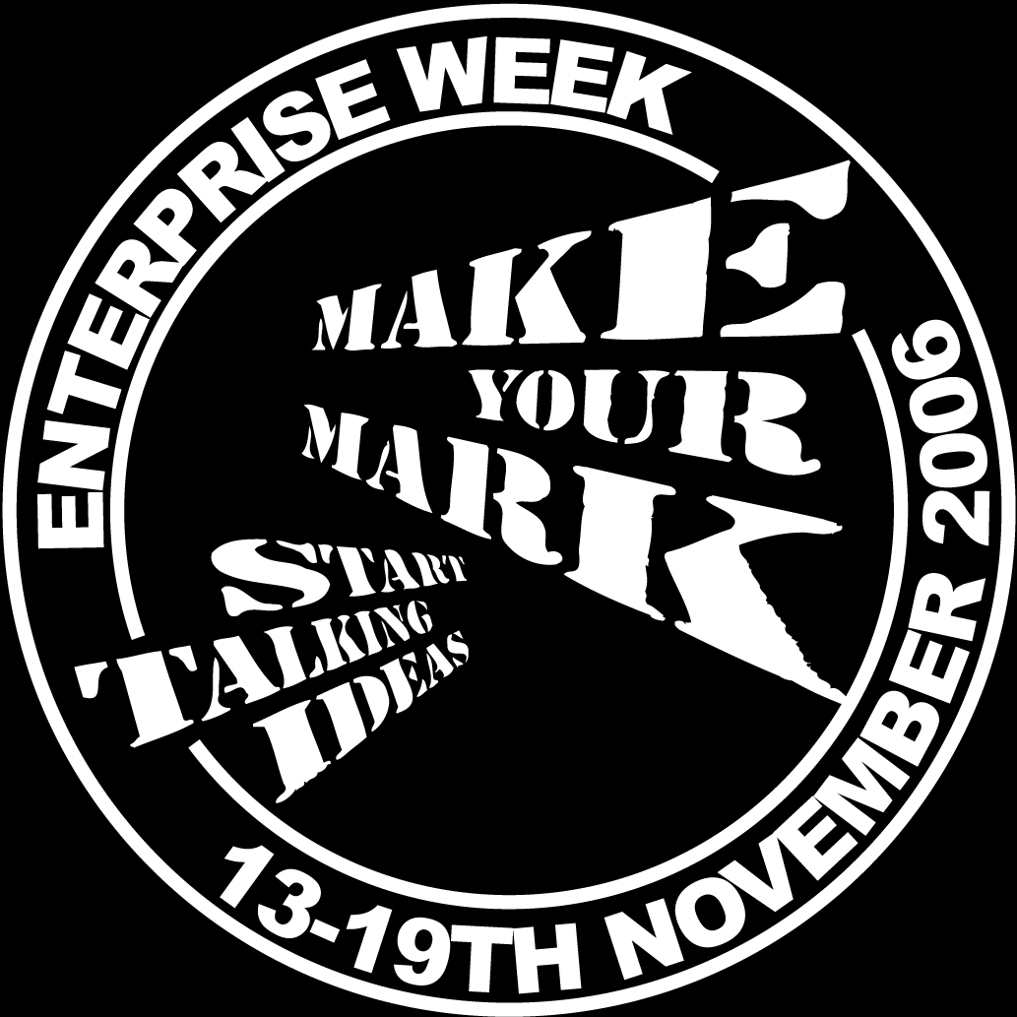
Enterprise Week. Only 1 week to go! Please visit the national website at www.enterpriseweek.org and look up Highcliffe School under South West region, and see all our enterprise events listed. There will be freebies going out to all KS4 and KS5 students and some for KS3 too. Thanks for all your help and support in putting Highcliffe on the Enterprise map!

Young Enterprise group - Year 12: The next board meeting will be Monday 6th November and not Tuesday 7th as scheduled. 1.20pm in the 6th form study room. Apologies to Vicky L Harris or Ryan Smith.

Sorry, but there is no S-Factor this week due to the Sixth Form Open Evening! S-Factor will be back on 16th November when you can make rice crispies fly & find the iron in other serious cereals! See you then!

MUSIC NOTICES
Tuesday after school: Harmonious Funk Jazz Band in EX3 3.20 - 5.00pm

Wednesday lunchtime: SHOUT! vocal group in EX3 1.40-2.10pm

Wednesday lunchtime: Vocalis vocal group in EX3 1.40-2.10pm

Wednesday after school: SHOUT! vocal group FOR ALL WHO HAVE SMALL GROUP AND
SOLO PARTS IN THE MUSICAL in EX3 3.20-4.30pm

Thursday lunchtime: Theory Workshop EX3 1.40-2.10pm

THURSDAY AFTER SCHOOL: FULL REHEARSAL FOR THIS YEARS MUSICAL in EX4 3.20 -
5.00pm

SPORTS NOTICES
Results:
Year 9 netball v Arnewood - won
Year 8 netball v Arnewood - lost
Years 10/11 football v Parkstone Grammar - lost
Year 8 football v Ashdown - won
Year 11 rugby v Arnewood - won

BRAIN TEASER
A number of children are standing in a circle. They are evenly spaced and the 4th child is directly opposite the 19th child. How many children are there altogether?

Answers to be submitted with your name and tutor group in the Brain Teaser box in Ma6 Before Friday 10th November.

The winner of last week’s Brain Teaser was Molly Atack of tutor group 77. Well-done Molly.

Look out for Molly receiving her prize on the plasma screens.

ENLIGHTENING ECO-FACTS!!!

We now use on average over 3.2 million tonnes of plastic and cardboard a year for packaging; twice what we used 10 years ago. And each household in Britain uses 323 supermarket bags a year.

So you all know what to do...Get the shopper in your family to re-use shopping bags or get a supermarkets own extra-strong one, and recycle all paper, plastic and card.

